**ICN NP/APN Network Bulletin November 2023**

*Editor: Colette Henderson RN, NISP, RNT, MSc, BSc (Hons) NP, FHEA*

# **Welcome to the November Network Bulletin**



**A very warm welcome to the ICN NP/APN November 2023 Network bulletin.**

In this month’s edition we report back from an amazing ICN Congress in Montreal in July! The Network was delighted to raise the profile of Advanced Nurse Practice globally, with many thought-provoking discussions with global colleagues.

Inside this bulletin you will find details about the next ICN NP/APN Network conference in Aberdeen, Scotland in 2024 on page 3, where we have shared some of the details about the progress of this conference development. The Network is pleased to congratulate some of our members on achieving a Legacy Award from the Executive Committee of the Fellows of the American Association of Nurse Practitioners (FAANP) (page 4) and international advanced practice features on pages 5-12. We have details of advanced practice nurse developments from China, Rwanda and Finland.

We look forward to seeing many colleagues and friends at the ICN NP/APN network conference in September 2024! We hope you enjoy reading this bulletin! Please consider contributing to the bulletin and raising the profile of the work you are doing. If you are interested in contributing, please contact the editor: [Colette Henderson](mailto:c.m.j.henderson@dundee.ac.uk)

# **Table of Contents**

Welcome to the November Network Bulletin 1

ICN Congress Montreal 2023 2

Save the date! 3

Congratulations from the Network 4

The gap between education and practice: the experience of Nurse Practitioners in China 5

Implementation strategies for safer administration of look alike, sound alike medication at the University Teaching Hospital of Kigali, Rwanda 7

Finland - Promoting advanced practice nursing through national collaboration 9

Research Study 12

# **ICN Congress Montreal 2023**

ICN Congress 2023 ***Nurses together: a force for global health***

The NP/APN network shared a booth with the ICN and held several discussions during congress. The sessions of particular interest to advanced practice nurses, included Policy Cafés, one on 2 July on Certification of Specialized Practice for APNs, and another two Policy Cafes on 5 July: ‘APN Guidelines for Nurse Anesthetists’ and ‘Pool of Nursing Experts Policy Café’ where CGNC certified Global Nurse Consultants including our Chair Dr Daniela Lehwaldt shared notes on Leadership and global practices. A Symposium on 3 July related to APN Research, Leadership and the UN SDGs in Action; and a Symposium on 4 July on the Certification of APNs.

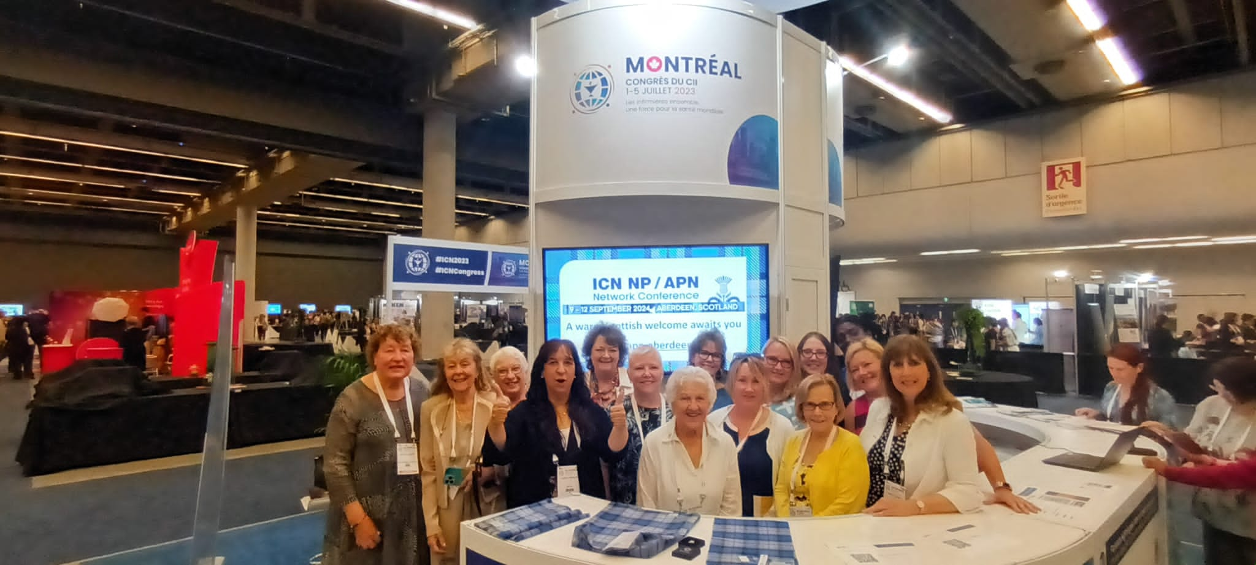

*Image 1: Members of the ICN NP/APN network at the ICN booth - ICN Congress Montreal 2023*

# **Save the date!**

We hope to see many colleagues at the ICN NP/APN Network Conference Congress in Aberdeen, 9-12 September 2024. Visit the website to find out more about this event: [NP/APNN 2024](https://www.delegate-reg.co.uk/icn-npapn-2024)

Work is underway to develop the ICN NP/APN Network conference and full details about the developments including the programme and details about abstract submission can be found on the website. We look forward to welcoming you to Scotland!

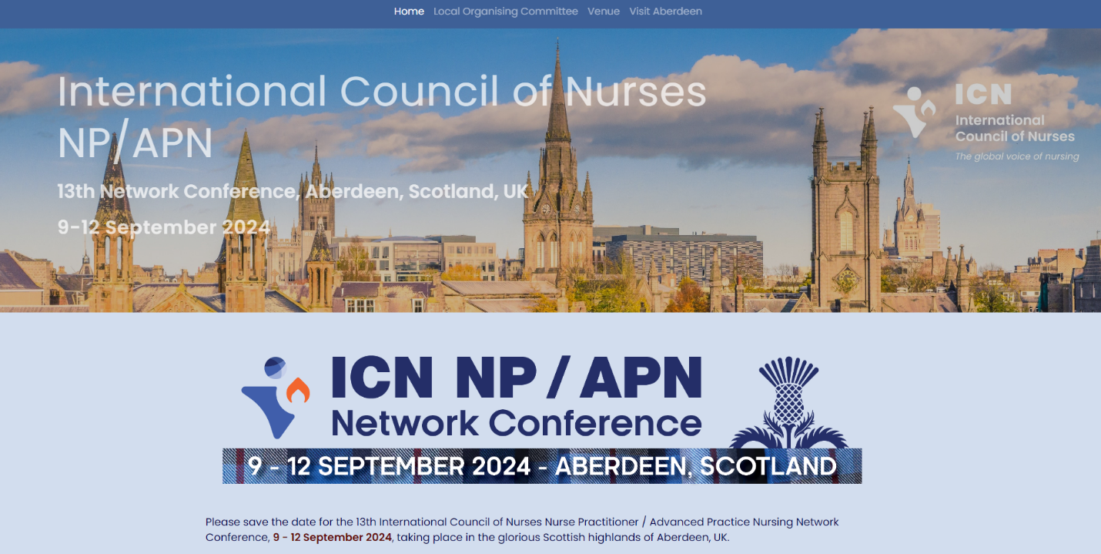

# **Congratulations from the Network**

A few of our alumni (Lorna and Joyce) will be recognized at the AANP National conference in June with the Legacy Award.

The Executive Committee of the Fellows of the American Association of Nurse Practitioners (FAANP) is pleased to announce the recipients of the 2023 Legacy Award**.** The FAANP Legacy Award honours, recognizes and memorializes a member of FAANP whose lifelong career has had a profound and enduring impact on the profession and the NP role, articulating a dream that others share and follow. The vision, innovation, courage, persistence, and inspiration of the honorees are essential components of the legacy. The 2023 FAANP Legacy Awardees are:

**Joyce Pulcini, PhD, PNP-BC, FAANP, FAAN**

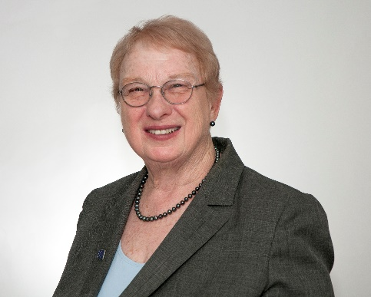

Dr Pulcini is a professor emerita at George Washington University. She is an expert in primary care practice and advanced practice nursing policy nationally and internationally and has directed NP programmes at several universities.  Her research focuses on the evolving nursing roles and education of nurse practitioners nationally and internationally and removal of barriers to NP practice. Dr Pulcini is the 2019 Towers Pinnacle Award recipient. Her scholarship includes more than 80 peer reviews publications, including her 2020 book with Dr Susan Hassmiller, entitled Advanced Practice Nursing Leadership: A Global Perspective.

**Lorna Schumann, PhD, FNP-C, ACNP-BC, ENP-C, ACNS-BC, FAANP, FAAN**

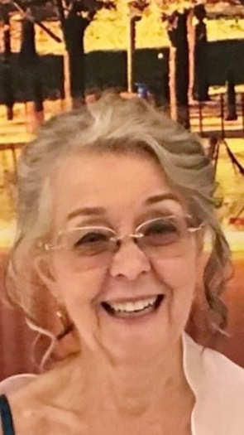

Dr Schumann is a recognized clinical expert in family practice and acute care. Her clinical expertise is varied and includes inpatient and outpatient work covering the full array of clinical conditions. She currently works in a homeless clinic.  Dr Schumann is also involved in the education of nurses and nurse practitioners in countries without adequate health resources. She has worked in Crimea, Ukraine, Egypt, Liberia, Burundi, Ecuador, Honduras, Guatemala, India, Thailand, and Vietnam and is enthusiastic about helping people in countries that lack resources for health care and health education.

# **The gap between education and practice: the experience of Nurse Practitioners in China**

# *Authors: Rongsong Tang1, Jingpin Wang1, Baohua Li1, Mingzi Li2 Affiliations: 1. Department of Nursing, Peking University Third Hospital, Beijing, China; 2. School of Nursing, Peking University, Beijing, China.*

**Background**

Nurse practitioners (NP) have become an important part of Global Healthcare System and in November 2022 there were more than 355,000 nurse practitioners in the USA. Previous studies showed that an NP presented similar outcomes and was more economical relative to medical doctors. Peking University introduced the first NP master’s degree programme in 2017 in response to the lack of general practitioners (GP) in primary care settings of China. The first NP graduates from this programme have practiced for nearly three years now.

**Objectives**

To explore the gap between the education and practice of NP’s and identify methods to reduce variance.

**Methodology**

This is a case report study of the first NP graduates from Peking University.

**Findings**

The three-year Master level education programme was designed mainly according to the international standards of NP education and the Master level training programme of GP of Peking University, including theoretical courses and clinical practice. Theoretical courses included general courses and NP-related courses. And clinical practice was a 24-month training programme consisting of nursing practice and medical practice with a time ratio of 1:1. The purpose of nursing practice and medical practice is to teach students regular nursing care skills through nursing rotation, the diagnostic and therapeutic skills through residency-like clinical rotations, respectively.

However, up to now in China the diagnosing and prescribing rights are just given to physicians, which means NPs cannot practice as they expected and trained. Therefore, as a matter of fact, NP graduates had to play the roles similar as clinical nurse specialists. Given the insufficient clinical practice experience of the new NP graduates, they received one year training in a specialized nursing practice. After that they started their attempt to build new service modes of NP practice. One NP has been working at a tertiary hospital. She implemented inpatient consultations, conducted whole-hospital blood glucose management and provided diabetes case management at outpatient clinic with the function of assessing patients' diabetes management behaviors and the levels of glycemic control, administering lifestyle interventions, and referral those who needs to endocrinologist. Another NP has been working at a community hospital affiliated to the tertiary hospital, conducting patients’ assessment, patients’ managements, lifestyle intervention and transfer treatment to GP via diabetes case management clinics. Meanwhile, she made health records and followed the patients with chronic diseases living in the community.

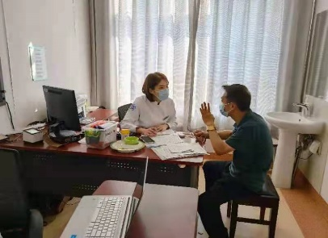 ***Image 1: NP providing case management***

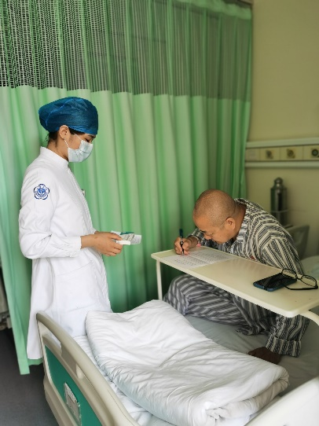

***Image 2: NP providing inpatient consultation.***

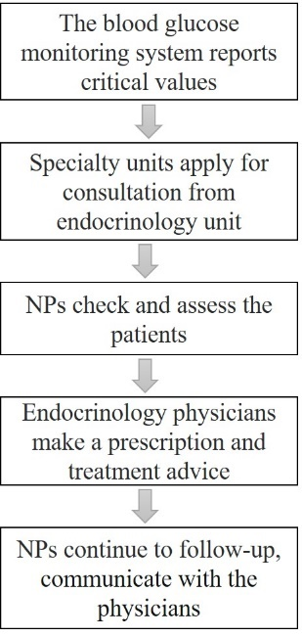

***Figure 1: The workflow for an NP conducting whole-hospital blood glucose management.***

**Conclusion and recommendations**

The main gap between education and practice of NP in the first master’s degree programme may be that too much emphasis was paid to diagnosis and treatment ability education while in the practice setting the NP role is more like a CNS. The specialized nursing training in the NP programme needs to be strengthened.

**The significance of the study specifically for advanced practice nursing**

Relevant laws and regulation rules relating to APN practice are crucial not only to practice, but also education. At the infant stage of NP education and practice, clinical needs and practice feasibility should be particularly considered to obey the running laws and regulation rules.

**References**

America Association of Nurse Practitioners (2022). NP fact sheet. [2023-04-25]. http：//www.aanp.org/about/all-about-nps/np-factsheet.

Liu CF, Hebert PL, Douglas JH, Neely EL, Sulc CA, Reddy A, Sales AE, Wong ES (2020). Outcomes of primary care delivery by nurse practitioners: Utilization, cost, and quality of care. *Health Serv Res*. Apr;55(2):178-189.

Tang RS, Lu Y, Jiang H, Jiang XJ, Zhou N, Li MZ, Shang SM (2020). Current situation and enlightenment of practicing and prescribing rights of practicing nurses [J]. *Chinese Journal of Nursing*, 55(05):796-800.

# **Implementation strategies for safer administration of look- alike, sound-alike medication at the University Teaching Hospital of Kigali, Rwanda**

*Author: Valens Musengamana, RN, MScN*

**Background**

Patient safety is a serious global public health concern. The cost of medications error is estimated at 42 billion USD annually worldwide. Adverse drug events appear to be a leading cause of injury in high-, middle- and low-income countries. Confusions involving look-alike/ sound-alike (LASA) drug names continue to threaten patient safety. The **aim** of the project was to implement strategies to prevent medication errors and promote patient safety at Kigali University Teaching Hospital in the pharmacy department.

**Methodology**

A checklist was developed in order to evaluate the implementation of LASA policy. The project monitoring was done day to day and the evaluation was performed after 3 months.

**Results**

The project was implemented at 88%. The interventions implemented were: 1) update LASA policy with current evidence, 2) creation of a list of confusing LASA medication names using tall man lettering, 3) store LASA medication by using uniform warning labels throughout the respective facility to facilitate identification (blue color labels), 4) create an inter-professional collaboration pathway between units and pharmacy team 5) build capacity regarding medication error prevention at the pharmacy department by putting strategies in place. The project contraints was to obtain enough labels hospital; the procurements process will be used and are beyond the timeline.

**Conclusion**

This study is on implementation strategies for safer administration of LASA medication. These will prevent patients harm from medication error and will result in service delivery improvement.

**What is already known on this topic in advanced practice nursing?**

A study at Kigali University Teaching Hospital in 2017 found that 39% and 45% of nurses do not report medical error if they are only the one who discovered the errors.

Proposed solutions for overcoming medication errors are: Reducing interruptions and distractions, storage strategies, typographic intervention, e.g., tall man lettering, barcoding, computerized physician order entry.

**What does this project add to advanced practice nursing?**

The key activities from the project were to update LASA medication policy with current evidence, elaborate a list of LASA medication using tall man lettering, store LASA medication by using uniform warning labels throughout the respective facility to facilitate identification, create an inter-professional collaboration pathway between units and pharmacy team, build capacity regarding medication error prevention at the pharmacy department.

**The specific significance of the project to advanced practice nursing**

Implementation strategies for safer administration of look-alike/sound-alike medication at the University Teaching Hospital of Kigali reduced medication errors. The project put in practice the strategies that improved patient safety and decreasing patient harming from LASA medication. Also, the hospital leadership may be aware of the medication errors, and can develop, implement and sustain appropriate policies and strategies to improve patient safety. The clinicians can better identify the potential for errors by staying alert to the specific medications that cause the most confusion in individual practice settings.

In nursing/midwifery, this quality improvement project contributed to the existing strategies improving patient safety.

# **Finland – Promoting advanced practice nursing through national collaboration.**

*Authors: Krista Jokiniemi, RN, PhD, University of Eastern Finland, University Lecturer, chair of the APN expert working group ; Anna Suutarla, RN, PHN, M.Sc. Finnish Nurses Association, Senior Advisor, coordinator of the APN expert working group; Anna Axelin, RN, PhD, University of Turku, Associate Professor; Mervi Flinkman, RN, PhD, The Union of Health and Social Care Professionals in Finland (Tehy), Senior Advisor; Sini Hämäläinen, RN, MHC, LAB University of Applied Sciences, Senior Lecturer; Jaana Kotila, RN,MnSc, Helsinki University Hospital (HUS), eHealth services, Development manager; Tuija Lehtikunnas, RN, PhD, Turku University Hospital, Hospital Director of Nursing; Virpi Sulosaari, Turku University of Applied Sciences, Principal lecturer; Annukka Tuomikoski, RN, PhD Oulu University Hospital, The wellbeing services county of North Ostrobothnia, Director of Nursing Competence*

**Introduction**

In 2023, Finland implemented one of the largest reforms in the social and healthcare system in its history. The changes also brought an opportunity to advance advanced practice nursing integration in the new social and healthcare structure and new job opportunities for healthcare professionals. However, due to slow changes in the career perspectives of nurses and in the healthcare system, the know-how and potential of APNs has not been utilized to the full extent. The growing shortage of nursing professionals forces the government to add more emphasis on clinical career path opportunities for registered nurses.

**Background**

In Finland, the education for advanced practice nurses (APN) began in universities and universities of applied sciences at the beginning of the 21st century. The first APN posts were established in the university hospitals at the same time. advanced practice nursing (APN) roles are country specific. Therefore, in 2016, the first Finnish Nurses Association APN expert working group was appointed to clarify and describe advanced practice nursing roles in the country-specific context in Finland. Currently two APN roles are recognized: clinical nurse specialist (CNS) and nurse practitioner (NP). In addition, the role of specialist in clinical nursing science exists in one university hospital. The role of nurse informatic (NI) has been established in the healthcare sector. However, there is still no national consensus or regulation on these roles in social and healthcare. In Finland, special authority for limited prescribing for registered nurses is a separate education and a regulated extended role. This role is mainly implemented in primary health care.

In 2016, the first expert group recommended

1. The job descriptions of APNs have to be defined, titles unified, and legislative changes examined.

2. Nursing education must be developed to meet the needed competencies.

3. The number of APNs must meet the health requirements of the Finnish population.

4. The specialist job description must be seen in the salary of the nurse.

5. The effectiveness of APN job descriptions must be evaluated and followed.

Some of the recommendations have progressed but there is still no national consensus or regulation for APN roles and education. Moreover, information on the state of APNs was somewhat scattered and it was seen as important to identify the progress since 2016.

**Methods**

A new APN expert group for the Finnish Nursing Association was established in 2021.

The members of the 2nd APN expert group represented nursing practice, education, research, nursing leadership, and trade union. The collaborative work included a scoping review of scientific literature to capture the current state of APN research in Finland, focus group interviews (N=31) on APNs´, nurse leaders´, and educators' perspectives on the current state of APN, and the development of fact sheets on the APN roles for communication actions and recommendations for future role development. In addition, the expert group participated in the Nursing Research Foundation Sr (NRF) development process of updating the Action Model of Expertise for Evidence-Based Health Care (EBHC).

**Results**

The scoping review of the literature revealed moderate research (n=19) on the APN roles within Finland. One of the challenges is that the titles used in the APN roles vary. Based on the interviews, the role of APNs varies according to the organization’s capability and resources to utilize the full potential of the APN role. In best case, the role was well-established and independent and thus improved the quality of patient care. However, APNs were often used as a substitute for nursing staff which in turn limited the full use of their expertise or their role was not acknowledged within the organization. The updated Action Model of Expertise, including five different types of experts and their core competencies, was introduced as a means of facilitating EBHC in Finland.

In addition, the expert group made the following recommendations:

1. APN roles and education should be established by a national advisory board.

Initiatives relating to the regulation of tasks, skills recognition, and the harmonization of qualifications should be coordinated at the national level. During the 2023-2027 government term, a nursing division of the Advisory Board of Health Care Professionals, established by the Ministry of Social Affairs and Health, should be set up. We recommend that this section, in its upcoming period of operation, review and make recommendations on APN roles that require a Master´s level degree (University of Applied Sciences/University). A national model and systematic implementation and monitoring will contribute to the optimal allocation of resources.

1. There needs to be close collaboration between the educational system and working life

Collaboration and networks between the education system and working life should be strengthened for developing APN roles. Collaboration must be implemented across the board, from the highest national level to individual organizations. This will ensure that the education system produces the skills needed by working life, including in terms of continuous education. Close collaboration between the education system and working life must reflect the health needs of the population and take account of future challenges, such as population aging.

1. Wellbeing Services Counties should systematically use and increase APN job roles

There is a need to increase the number of APN roles in Wellbeing Services Counties, both at primary and specialized levels and in services for the elderly, both in service housing with 24-hour assistance, and in-home care. Making full and optimal use of the skills of advanced practice nurses is important for prevention, access to care, health promotion ensuring evidence-based care, and developing technology and digitalization. APN roles are an essential part of nurses' clinical career paths, the development of nursing and clinical support structures, thus playing an important role in the sector’s professionals' retention and attractiveness as an employer.

1. APNs should be involved in development working groups on health and social services.

APNs have expertise in wellbeing, health, nursing development and research, and evidence-based practice. This expertise should be used in nursing and multi-professional development teams to develop the functions of the social care system and crisis preparedness.

1. Organizations need to produce and analyze data for evaluating the effectiveness of APNs

More information is needed on the effectiveness and cost-effectiveness of APNs in different areas of nursing. Uniform nurse-sensitive indicators should also be introduced in the area of advanced practice nursing. Consistent data on effectiveness produced by organizations will enable the study of tasks and support future decision-making and the development of task profiles and training.

**Conclusion**

Harmonization of APN roles is needed as it promotes the understanding and utilization of full APN potential. The social and healthcare system in Finland is under transformation and it is restructured to meet the changing population needs. It is a critical time to continue the systematic implementation as well as influencing and policy work of APN roles to secure patients’ access to high-quality social and healthcare services and retention of expert workforce.

**References**

International Council of Nurses. (2020) Guidelines on Advanced Practice Nursing. Available at <https://www.icn.ch/system/files/documents/2020-04/ICN_APN%20Report_EN_WEB.pdf>

Jokiniemi, K., Suutarla, A., Axelin, A., Flinkman, M., Hämäläinen, S., Kotila, J., Lehtikunnas, T., Palomaa, M., Sulosaari, V. & Tuomikoski, A. (2023) Laajavastuinen hoitotyö - sairaanhoitajan uramalli lähellä ihmistä. Finnish Nurses Association. Available at: <https://sairaanhoitajat.fi/wp-content/uploads/2023/04/APN-raportti-2023_final.pdf>

Kotila, J., Axelin, A., Fagerström, L., Flinkman M., Heikkinen, K., Jokiniemi, K., Korhonen, A., Meretoja, R. & Suutarla, A. (2016) New roles for nurses – quality to future social welfare and health care services. Finnish Nurses Association. Available at: <https://sairaanhoitajat.fi/wp-content/uploads/2020/01/new-roles-for-nurses.pdf> **Useful resources**

Report of the first APN expert group (2016): <https://sairaanhoitajat.fi/wp-content/uploads/2020/01/new-roles-for-nurses.pdf>

Report of the second APN expert group (2023, in Finnish) to be published in English: <https://sairaanhoitajat.fi/wp-content/uploads/2023/04/APN-raportti-2023_final.pdf>

Video clips on APN work in Finland: <https://www.youtube.com/watch?v=Z6n2MsEx-DQ&t=7s>

Nursing Research Foundation (NRF) Action Model of Expertise for Evidence-Based Health Care (EBHC): <https://www.hotus.fi/wp-content/uploads/2023/04/finame-en-final.pdf>

# **Research Study *** PARTICIPANTS NEEDED! \*\*\***

We are offering 6 x 1-hour supervision sessions of Resilience Based Clinical Supervision (RBCS) for Advanced Practice Nurses and Nurse Practitioners and would like YOU to participate!

**What is RBCS?** RBCS is a supportive forum that will increase your ability to respond positively to the emotional and physiological demands of your role. It was developed by the Foundation of Nursing Studies in the United Kingdom and has been successfully utilized for student nurses, nurses and Advanced Practice Nurses.

**Why RCBS for APNs/NPs?** Members of the ICN NP/APN Network undertook a longitudinal study investigating APNs’ emotional and spiritual wellbeing during COVID-19. They found that the wellbeing and resilience of APNs and NPs were severely impacted and continued to be 18 months into the pandemic. In response to this, the researchers offered a RBCS pilot study last year which evaluated as an excellent response to support APNs and NPs. In response to the pilot, the ICN NP/APN Network is offering its members the opportunity to take part in a global RBCS group from January 2024.

**What will I be asked to do?** Starting in January, you will participate in 6x1-hour virtual supervision sessions over five months. These will be facilitated by trained RCBS supervisors who are also APNs. Before the first session and after the last session you will be asked to complete a short online survey about your wellbeing and resilience. You will also be asked to provide a short evaluation of the programme after its completion. You are free to withdraw from the research at any time before data collection without giving any explanation.

**What will you do with the survey I complete?** We will analyze your surveys and evaluations to learn more about the role of RCBS in APN and NP wellbeing. We hope to publish these results. Th results will not be linked back to you in any way. This research has been reviewed and approved by the University of Huddersfield’s School Research Ethics and Integrity Committee (SREIC).

**I’m interested! Who do I contact?** Please email Sabina Staempfli at [sabina.staempfli@ubc.ca](mailto:sabina.staempfli@ubc.ca) if you are interested in participating in this study. We look forward to hearing from you!